

**The Arab American University**

Faculty Of Engineering and Information Technology

Computer Systems Engineering Department

**Senior Project I**

**Mobile Application for Renting stuffs**

***Prepared By:***

**Muna Yassin 201612097**

**Jana Hamarsheh 201710451**

**Razan Thaher 201611769**

***Supervisor : Mahmoud Saleh Obaid.***

**Submitted in Partial Fulfilment of the Requirement for the Degree of Bachelor of Computer Systems Engineering**

**February 2021s © Arab American University – Palestine**

**Jenin-2021.**

**All Rights Reserved**

Abstract

**2.1 Overview**

As we all know that nothing starts from Zero, so our project also the same in this part we will present several existing systems that are similar to our project, but not completely the same. Most of These applications made to do one or two function at all, so our application will take the advantage and include them all in one super application.

**2.2 Existing Systems**

As we mentioned before that most of the applications focus on renting houses and cars, it is rarely to find applications for renting stuffs, but we found some of existing renting stuffs applications that presenting different services, functions and locations.

**2.3.1 Idle**

Renting application that allows you to rent stuffs from people around you, it has a delivery feature that allows you to select their drivers or stuffs owners or you can take it by yourself with guarantee to cancel your order anytime because it has no electronic payment way like credit card or PayPal.

Also it has a feature that allows you to put your stuffs inside lists.

It gives you the calendar as a feature to let you know when are you going to rent the stuff.

Finally, it has Earning feature that inform you how much money you earned from the stuffs you rented out.

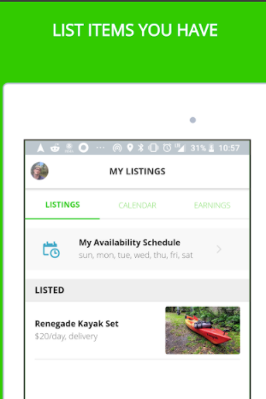

**2.3.2 Rent Your Stuff**

This application allows you to rent out your stuffs and earn money and sorting them in categories like electronics, books, home and gardens.

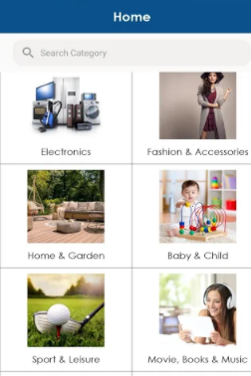

**2.3.3 All4Rentz**

This is a new application started from lockdown it allows you to rent anything from a-z.

In this application you can specify what the rental plan you want “per month, per year, per day... etc.”

 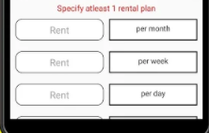

**2.3.4 Airbnb**

We all tried or at least know this This amazing application for renting houses, especially if you’re travelling in groups. this application gave us the idea to build our project, it has so many different amazing features like evaluation, rating, comments this features gives you others opinion about the houses they rented, we are going to use these features but for the stuffs.

